Task 2: Access Control

Task 2a
Introduction
This report aims to detail the process of an administrator with sudo rights configuring a share-folder and other subfolders under it. It will also show how users with different permissions can access the system.

The user which will be performing these steps are on with administrator rights (User: fit2093).

New User Groups
Two new user groups Human Resources (hr) and Public Relations (pr) are created using the “addgroup” command.
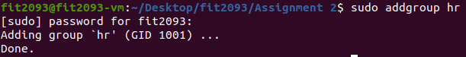

New Users
Two new users “nancy” and “ryan” are created using the “adduser” command.
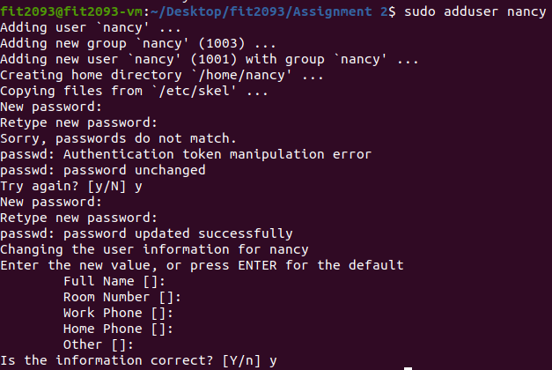
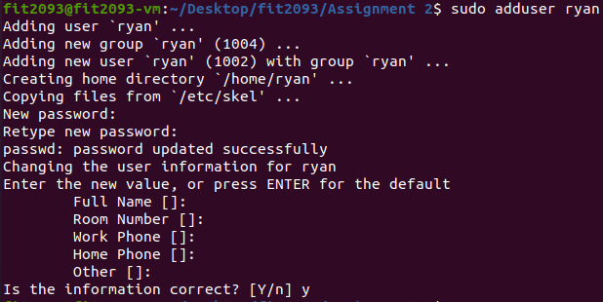

Next, “nancy”, who is in both groups “hr” and “pr”, and “ryan”, who is only in group “pr”, are added to their respective groups using the “adduser” command.
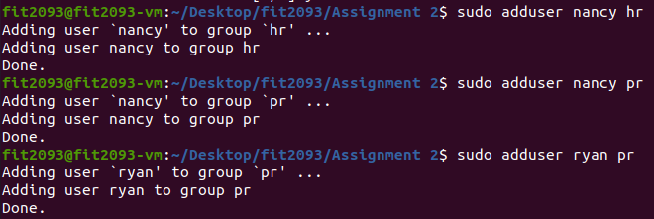

Contents
Using the command below, it can be observed that the users are correctly added to their respective groups.
Output:
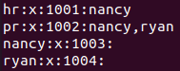

Nancy has access to both “hr” and “pr” as well as her home directory “nancy” while Ryan has access to only “pr” and his home directory “ryan”.

Task 2b
Folders and Access
As a user with administrator rights (fit2093), folders can be created, and their permissions can be set.

First, login as fit2093 (admin).

The share-folder is created with the command below.

The subfolders pr and hr are created with the commands below.

The groups pr and hr are then assigned to their corresponding folders with the commands below.

The permissions for these groups are set using the commands below. 770 means that the owner and group member can read, write and execute while anyone else has no access to these folders.

User Access
The outcome of Nancy and Ryan accessing the two folders is shown below. Nancy is a group member of both hr and pr while Ryan is only a group member of pr.

First, Nancy logs in.

Nancy creates a text file in the hr folder using the command below.

Next, Ryan logs in.

Ryan creates a text file in the pr folder using the command below.

When Ryan attempts to open the files, he is able to open the file in pr but is denied access to the file in hr.

When Nancy attempts to open the files, she is able to open both the files in pr and hr.

Task 2c
Readsecret Permissions
First, the readsecret_x86.tar.gz is copied to the share-folder created earlier.

Using the commands below, the directory is changed to the share-folder and its contents are displayed.
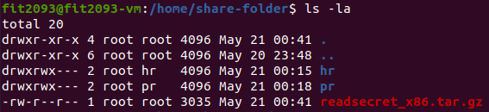

The file is executed which contains the following files:
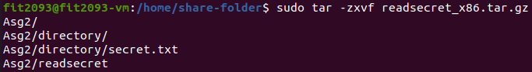

As seen below, “directory” can only be accessed by the owner which includes any file under it such as “secret.txt”. “readsecret” can be accessed by the owner and those of group “fit2093” but anyone else can only read and execute it.
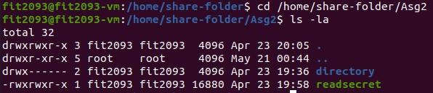

SUID permission for “readsecret” using the command below.
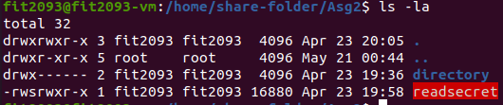

Readsecret Outcomes
This is what happens when users with different permissions directly access “secret.txt” and when they run “readsecret”

FIT2093 (fit2093):

Nancy (pr & hr):

Ryan (pr):

As observed above, while everyone can run “readsecret” to gain access to “secret.txt”, only those in the group “fit2093” can directly access “secret.txt”

Conclusion
In conclusion, by setting permissions and giving certain users the ability to interact with only specific parts of a system, we can maintain the security of the system by grating a user’s access to only what they are allowed to.

